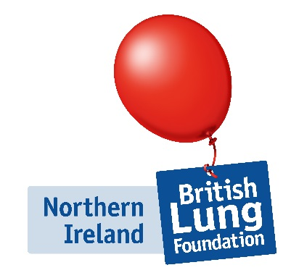
Healthcare Professionals Conference

Excellence and Innovation in

Respiratory Practice
Date 16th June 2017
Clayton Hotel
Address: 22 Ormeau Ave. Belfast BT2 8HS
Contact on the day: Nessie Blair M:0790204433
09.00 – 09.15 | Registration, coffee and exhibition viewing
09.15 – 09.25 | Welcome and introductions  Irene Johnstone, Head of BLF Scotland and Northern Ireland
09.25 – 10.15 | "Advances in COPD management and education".  Carole McGrath and Frances Barrett,  Barrett & McGrath Healthcare Solutions Consultancy Ltd.
Workshops – Delegates choose from:
10.15 -11.00 | WORKSHOP A  INTEGRATED BREATHE EASY  Jeremy Bacon  BLF Breathe Easy Manager | WORKSHOP B  MOTIVATIONAL INTERVIEWING  Dr Derek McLaughlin, Senior Lecturer in Mental Health Nursing at Queens University Belfast |  |  | WORKSHOP C  BEHAVIOUR CHANGE IN EXERCISE INTERVENTION  Rebecca Jones,  BLF Keep Active Keep Well Delivery Manager
11.00 – 11.15 | Tea/Coffee and exhibition viewing
11.15 – 11.50 | Adherence and monitoring in difficult asthma  Kathy Hetherington, Specialist Clinical Physiotherapist, Belfast Health & Social Care Trust & Queens University Belfast.
11.50 – 12.30 | Diagnosing lung cancer using modern assessment tools in radiology  Dr Tom Lynch, Consultant Radiologist, Belfast Health & Social Care Trust.
12.30 – 13.20 | Lunch and networking
13.20-13.50 | Singing for Lung Health  Karen Diamond, BLF Singing for Lung Health Leader.  Nessie Blair, MBE. Service Development Manager BLF Northern Ireland
13.50 – 14.20 | Virtual Respiratory Clinics  Dr Terry McManus, Consultant Respiratory Physician, Western Heath & Social Care Trust
Workshops – Delegates choose from:
14.20-15.05 | WORKSHOP A  INTEGRATED BREATHE EASY  Jeremy Bacon  BLF Breathe Easy Manager |  | WORKSHOP B  MOTIVATIONAL INTERVIEWING  Dr Derek McLaughlin, Senior Lecturer in Mental Health Nursing at Queens University Belfast | WORKSHOP C  BEHAVIOUR CHANGE IN EXERCISE INTERVENTION  Rebecca Jones,  BLF Keep Active Keep Well Delivery Manager
15.05 – 15.20 | Tea/Coffee and exhibition viewing
15.20 – 15.50 | An update on GOLD 2017 - making clinical sense out of further change  Dr Lorcan McGarvey, Consultant Respiratory Physician, Belfast Health & Social Care Trust
15.50-16.00 | Closing Remarks  Irene Johnstone, Head of BLF Scotland and Northern Ireland

This meeting is kindly supported by the following by
purchase of trade exhibition space:

Workshop descriptions

WORKSHOP A: Integrated Breathe Easy (BLF)

Presentation on BLF research on support groups and the role they play in reducing rates of unplanned GP visits and hospital admissions.

WORKSHOP B: Motivational Interviewing (Derek McLaughlin, UU)

This workshop will help the participant to understand what Motivational Interviewing is and how it works to assist people change. Areas covered will be resistance to change, exploring ways of reducing resistance to change, definition and principles of Motivational Interviewing and early strategies to help facilitate change in the person with respiratory issues.

WORKSHOP C: Behaviour change in exercise intervention (Rebecca Jones, BLF)

This workshop will cover the BLF Keep Active Keep Well programme and how behaviour change theory has been used to develop the intervention, as well as the delivery mechanisms to patients. The workshop will also share some learning to date around the programme.

